Yenepoya arts science,commerce and management
Project – Low Level Design
on
Smart City Cloud Billing — Cost Optimization Platform

Student Name:
AFSANA JABEEN PULIPRA

Industry Mentor: |  | Guided by: | Ms. Yuktha

Table of Contents
1. Introduction
1.1. Scope of the Document
1.2. Intended Audience
1.3. System Overview
2. System Design
2.1. Application Design
2.2. Process Flow
2.3. Information Flow
2.4. Components Design
2.5. Key Design Considerations
2.6. API Catalogue
3. Data Design
3.1. Data Model
3.2. Data Access Mechanism
3.3. Data Retention Policies
3.4. Data Migration
4. Interfaces

5. State and Session Management
6. Caching
7. Non-Functional Requirements
7.1. Security Aspects
7.2. Performance Aspects
8. References

1. Introduction
This Low Level Design (LLD) document provides detailed technical specifications for the Smart City Cloud Billing Cost Optimization Platform. It covers the concrete implementation details of every module — class structures, function signatures, logic flows, data structures, UI component bindings, and algorithm specifications — giving developers all the information needed to implement, extend, or maintain the system. The platform is implemented in Python 3.10 using Streamlit, Pandas, Matplotlib, and NumPy. It operates on a 144-record CSV dataset and presents a two-tab web dashboard: a read-only analytics Dashboard and an interactive Cost Calculator

1.1. Scope of the Document
This LLD document describes:
- Detailed module-by-module breakdown of app.py
- Function-level specifications including inputs, outputs, and logic
- Data structure definitions for all computed aggregations
- Widget-to-variable binding for all interactive controls
- Algorithm specifications for cost calculation and savings simulation
- Slider default derivation logic
- Chart rendering pipeline per visualization
- Security and performance implementation details

1.2. Intended Audience
- Python developers implementing or extending the system
- Technical reviewers and faculty evaluators
- QA engineers writing test cases
- DevOps engineers deploying the application

1.3. System Overview
The application is a single-file Streamlit app (app.py) with the following runtime structure:
- Entry point: streamlit run app.py
- Runs at: http://localhost:8501
- Dataset: cloud_billing_2024.csv (same directory)

- Python dependencies: streamlit, pandas, matplotlib, numpy
- Two tabs: Dashboard (read-only) and Cost Calculator (interactive)
- Sidebar: service and department multiselect filters

2. System Design

2.1 Application Design
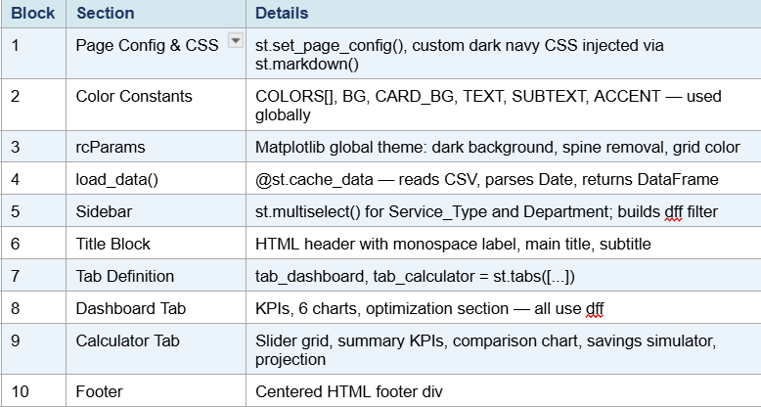
The application is structured in the following execution order within app.py:

2.2 Process Flow
Detailed step-by-step execution flow:
- Step 1: app.py executes — st.set_page_config() must be first Streamlit call
- Step 2: CSS injected — dark navy theme applied to all Streamlit elements
- Step 3: load_data() called — CSV read, Date parsed, returned as df
- Step 4: Sidebar renders — user selects services/departments
- Step 5: dff = df[filter conditions] — filtered DataFrame computed

- Step 6: Tab selected — Streamlit renders only the active tab's content
- Step 7 (Dashboard): annual, monthly, by_month_all, growth computed from dff
- Step 8 (Dashboard): 6 Matplotlib figures created, rendered via st.pyplot()
- Step 9 (Calculator): svc_actuals computed from unfiltered df; slider defaults derived
- Step 10 (Calculator): calc_totals{} built from slider values × unit prices
- Step 11 (Calculator): lever_values{} built from savings sliders
- Step 12 (Calculator): effective_pct = min(sum(levers)/100 × 0.65, 0.55)
- Step 13 (Calculator): projected_months list built with compound growth formula

2.3 Information Flow

cloud_billing_2024.csv → df (raw DataFrame) → dff (filtered)

dff → groupby aggregations → Matplotlib figures → st.pyplot()

df → svc_actuals{} → slider defaults → calc_totals{}

calc_totals{} → KPI cards, bar chart, donut chart

lever_values{} → effective_pct → sim_savings, sim_optimized

calc_monthly_total + growth_rate → projected_months[] → line chart

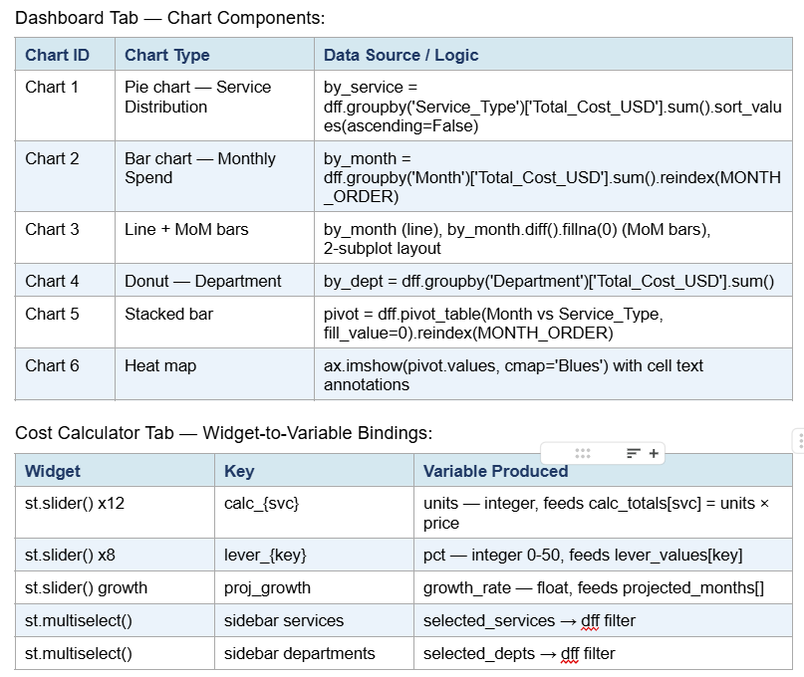
2.4 Components Design

2.5 Key Design Considerations
- Simple and user-friendly design
- Accurate cost calculation
- Easy integration with Excel
- Scalable for more cloud services

2.5 Key Design Considerations
- Single-file architecture — entire app in app.py for academic clarity and portability
- Global COLOR palette COLORS[] with 12 distinct values — one per service type
- plt.rcParams.update() applies dark theme globally before any figure is created
- plt.close() called after every st.pyplot() to prevent memory leaks across rerenders
- dff (filtered DataFrame) is the single source of truth for all Dashboard charts svc_actuals
- uses unfiltered df — calculator always reflects full dataset, not sidebarfilters
- max_value for each slider = default_units × 3 — allows 3× growth modeling
- Savings blending: raw sum × 0.65 prevents over-counting of overlapping optimizations
- 55% hard cap on effective_pct is based on industry benchmarks for cloud cost optimization
2.6 API Catalogue
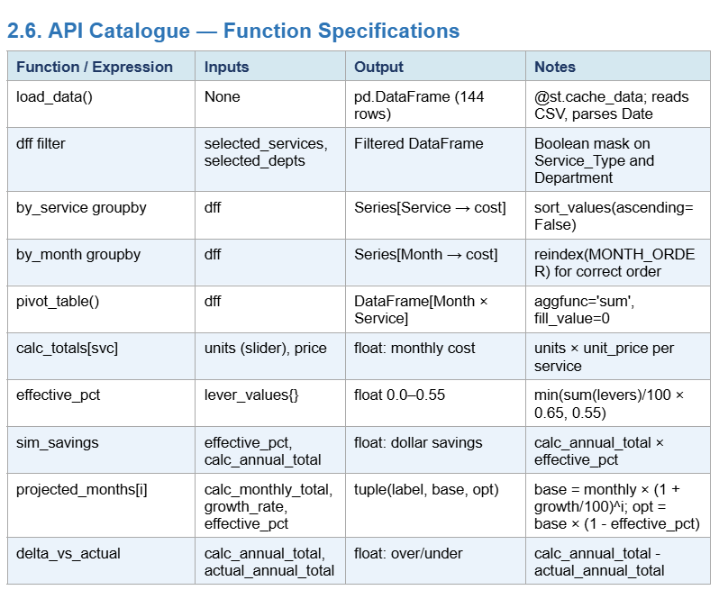

3. Data Design

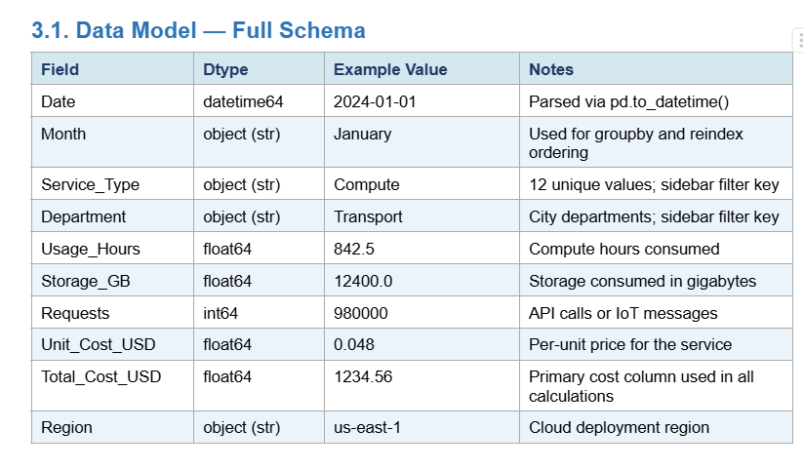
3.1 Data Model

3.2 Data Access Mechanism

Read operation:

df = pd.read_csv('cloud_billing_2024.csv')

df['Date'] = pd.to_datetime(df['Date'])

Filter operation:

dff = df[df['Service_Type'].isin(selected_services) & df['Department'].isin(selected_depts)]

Aggregations used:

by_service=dff.groupby('Service_Type')['Total_Cost_USD'].sum().sort_values(ascending=False)

by_month=dff.groupby('Month')['Total_Cost_USD'].sum().reindex(MONTH_ORDER)

by_dept=dff.groupby('Department')['Total_Cost_USD'].sum().sort_values(ascending=False) pivot = dff.pivot_table(values='Total_Cost_USD', index='Month', columns='Service_Type', aggfunc='sum', fill_value=0)

.reindex(MONTH_ORDER)

3.3 Data Retention Policies
- CSV source file is stored locally in the project directory
- No database, no cloud storage, no remote endpoints
- Session state (slider values) is held in Streamlit memory — lost on browser refresh
- Users may export analysis via Jupyter notebook using pd.ExcelWriter to smart_city_analysis.xlsx
- Exported Excel file contains: Raw Data, By Service, Monthly Trend, By Department, Heat Map Data sheets

3.4 Data Migration
- Current state:
- Manual CSV placement — cloud_billing_2024.csv in app directory
- Planned improvements:
- PostgreSQL integration: replace pd.read_csv() with pd.read_sql() using SQLAlchemy engine
- Live API feed: AWS Cost Explorer boto3 client → DataFrame → replace CSV load
- Azure Cost Management REST API integration Multi-year support: add Year column, extend MONTH_ORDER to Year-Month tuples

4. Interfaces
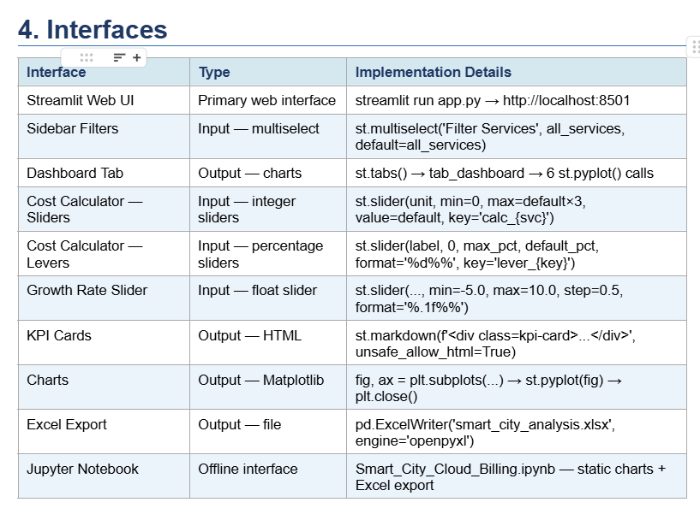

5. State and Session Management
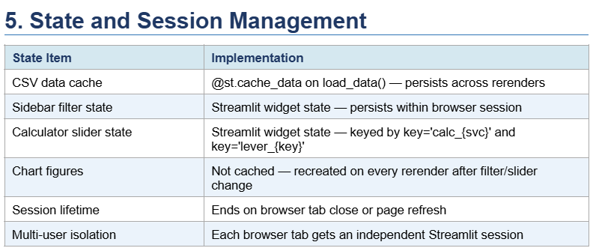

6. Caching
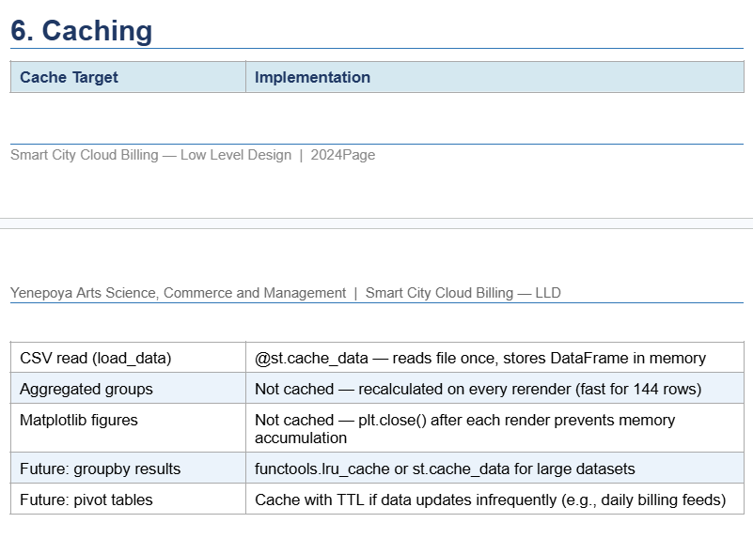


7. Non-Functional Requirements

7. Non-Functional Requirements

7.1 Security Aspects

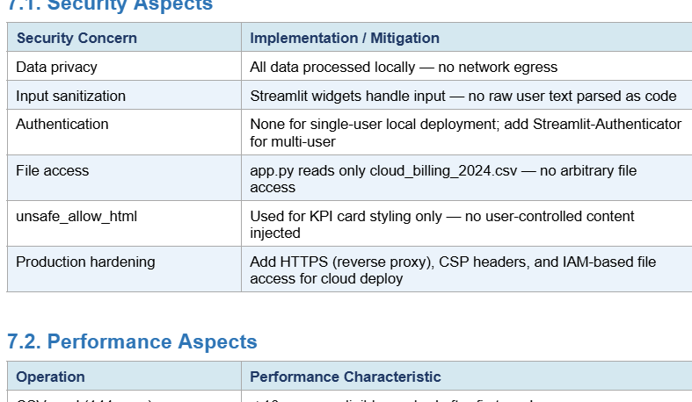

7.2 Performance Aspects

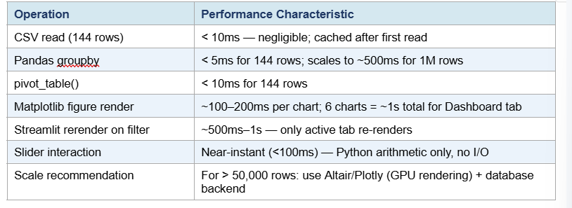

8. References

pthon 3.10 Documentation — https://docs.python.org

Pandas Documentation — https://pandas.pydata.org/docs

Matplotlib Documentation — https://matplotlib.org/stable/contents.html

Streamlit Documentation — https://docs.streaPymlit.io

NumPy Documentation — https://numpy.org/doc openpyxl Documentation — https://openpyxl.readthedocs.io

AWS Cost Explorer API — https://docs.aws.amazon.com/cost-management

Cloud Pricing Models — AWS, Azure, Google Cloud public pricing pages

Project Source Files: app.py, Smart_City_Cloud_Billing.ipynb, cloud_billing_2024.csV\

